**Partition initial Image to sub-Image**

Image size = rows : 960 columns:1280

Odd Row pixels = 270 to 760 = 490 pixels

490 / 7(columns) = 70 pixels each column (width of sub-image for odd rows)

Even Row pixels = 305 to 7725 = 420 pixels

420 / 6(columns) = 70 pixels each column (width of sub-image for even rows)

Columns pixels = 5 to 957 = 952 / 17 (rows) = 56 pixels ( height of sub-image)

Pixels

1 1280

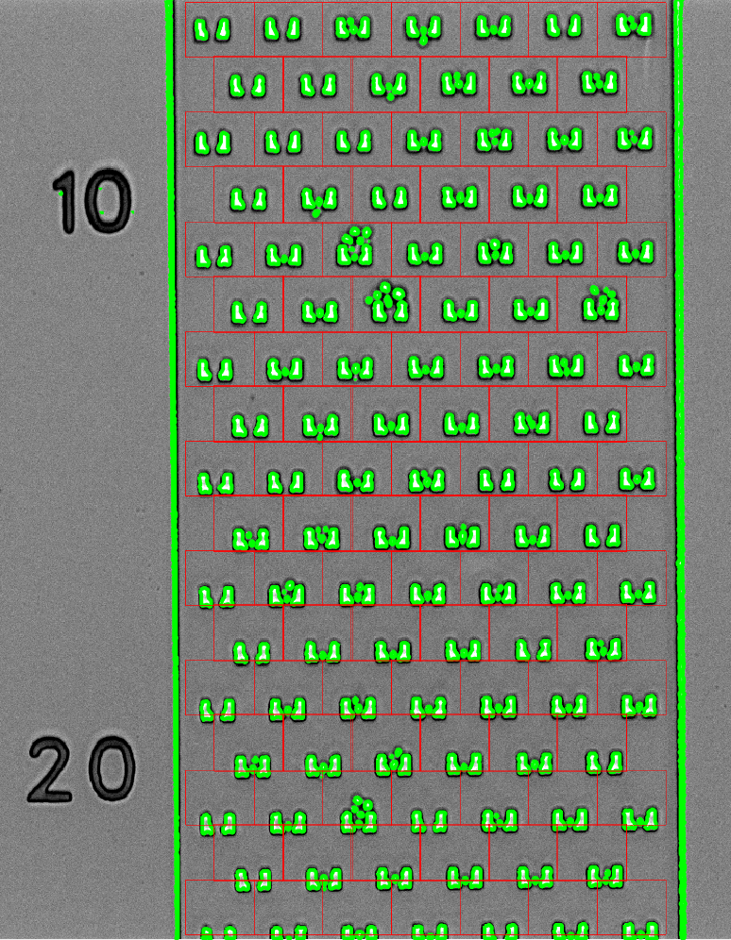

Trap position Issue:



It seems the interval A is smaller than B in first row of partitioning . There is a similar issue for following rows.

Such a problem creates uneven traps level and causing issue for partitioning as highlighted below:



This issue becomes more problematic as number of row increases from 1- 17

Row-1

1 2 3 4 5 6 7

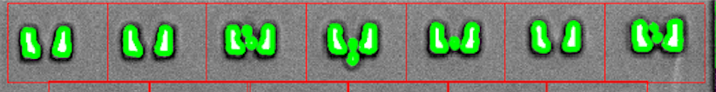

Row -4

1 2 3 4 5 6

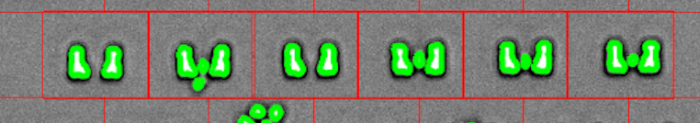

Row-10

1 2 3 4 5 6

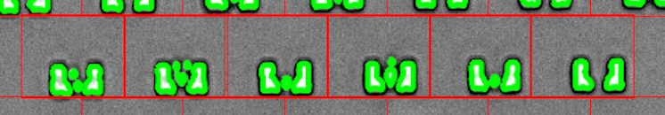

Row -14,15

1 2 3 4 5 6

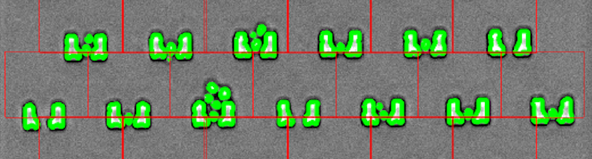

Row-17

1 2 3 4 5 6 7



Using different alignment methods and compare the out comes

Target area = sub-image from original image

Detected Cells = detected cells from sub-image ( removed traps)

Aligned1 = 1st method to align image between target area and BIN image

Aligned2 = 2nd method to align image between target area and BIN image

Aligned3 (a) = 3rd method to align image between target area and BIN image

Aligned3 (b) = 3rd method to align image between target area and BIN image

Green color : Reference Image (fixed image)

White color : Match area between two images

Pink color : target image (moving image)

